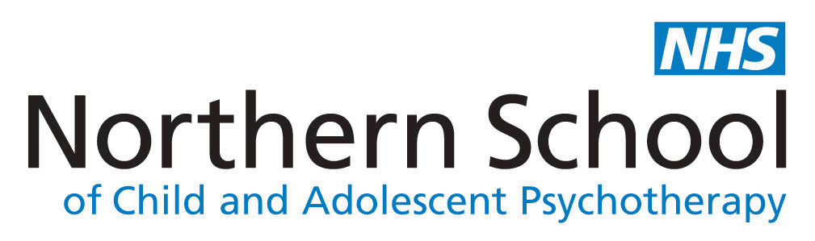

Haunting Issues: Children, Spectrality and Culture
Workshop 2: Mourning the Spectral Child (8th January 2024)
Programme
Venue: The Northern School of Child and Adolescent Psychotherapy (NSCAP)
34-36 Springwell Road, Leeds, LS12 1AW
Parking available on site

9:00-9:15am – Welcome and Coffee
9:15-9:30am – Introductory Remarks (Dr Lucy Arnold)
9:30-10:30am – Invested Objects: A Tabletop Presentation (Chair: Dr Chris Vardy)
This session will see a selection of network members use a material object as a jumping off point to discuss mourning the child in society and culture. The brief presentations will generate some of the strands of discussion which will be traced through the rest of the workshop.
10:30-12:00pm – Infant and Child Loss
Network Speaker: Dr Jen Baker (University of Warwick) - “Untimely Deaths: Textual, Visual and Material Disruptions of the Child”
This session will discuss the ways in which infant and child loss has the potential to register in culture and society in modes of willed forgetting, present absence but also in specific modes of memorialisation which complicate and potentially obscure the unique singularity of the specific child being mourned. It may also explore the potential for ambivalence towards the child who has died and the complex ramifications of their absence within the family and wider society.
Suggested Reading:
- Mary Wilkins Freeman, ‘The Lost Ghost’
- Charlotte Riddell, ‘Walnut-Tree House’
- “To Bereaved Mothers” & Chapter 1 (to p.19) of Meta Lander, The broken bud: or, Reminiscences of a bereaved mother
- Nancy West “Still Lives Photography Nostalgia and the Child Who Has Died” Photography and Culture, 9:2, (2016) 103-120 [CW: Images of child death and historical case studies]
12:00-12:45pm - Lunch
12:45-2:15pm – Narratives of Infertility
Network Speaker: Dr Lucy Arnold (University of Worcester) – “Spectres of the Unborn: The Child who Never Comes in Hilary Mantel’s Life Writing”
This session will explore experiences of infertility as articulated in works of cultural production, and societal and clinical narratives, and seeks to think about the ways in which the child who never comes into being but possesses a powerful existence in fantasy may come to obtain a spectral or phantasmic presence which exerts potent pressure upon cultural and familial narratives alike.
Suggested Reading:
- Hilary Mantel, Giving up the Ghost (2003), pp. 208-252.
- Hilary Mantel, ‘Clinical Waste’ in Jane Haynes and Juliet Miller (eds), Inconceivable Conceptions: Psychological Aspects of Infertility and Reproductive Technology (Hove: Brunner-Routledge, 2003), pp. 15-20.
2:15-2:30pm – Comfort Break
2:30-4:00pm – The ‘Looked After’ Child and Complex Absence
NSCAP Speaker: Laura Liddell
This session seeks to address the ways in which the removal of a child from a familial care giving situation by state institutions creates absences which are profoundly complex. Discussions may range across the coercive removal of children seen in historical cases such as the Irish Mother and Baby Homes, and the British ‘Home Children’ initiative, the removal of children into state care when their care givers are no longer able to appropriately care for them, and the experiences of parents and children in settings such as mother and baby units and in the prison system.
Suggested Reading: TBC
4:00-4:15pm – Coffee Break
4:15-5:00pm – Plenary Presentation and Closing Remarks

Registration:
For more information & to register contact: Network leader Dr Lucy Arnold, lucy.arnold@worc.ac.uk
Haunting Issues website: https://sway.office.com/GDltIdiqxke4eZ2c?ref=Link
For local information, please contact NSCAP on:
nscapadmin.lypft@nhs.net or phone: 0113 855 8750

