The Transpennine Partnership

Psychoanalytic Clinical Seminars

The Transpennine Partnership (TPP) in collaboration with NSCAP is delighted to announce the establishment of The Psychoanalytic Clinical Seminars in Manchester.

Outline
The second year will consist of two series of 5 monthly clinical seminars which will run on Friday evenings.

The seminars will be facilitated by senior psychoanalysts and psychoanalytic psychotherapists and will offer participants the opportunity to join an ongoing clinical discussion giving the opportunity to explore clinical work within a group setting using a psychoanalytic lens.

Each seminar will have a maximum of 10 participants and run monthly for one and a half hours. Seminars will be offered in blocks of 5 (there will be a discounted price for booking two blocks).

We anticipate that the first series will be run by Zoom. The second series will hopefully run in person depending on how the COVID situation develops.

Cost
The cost of the first series of seminars is £200 which takes into account that these will be offered remotely. The second series will be £260. Booking both series are offered at the discounted price of £400.

Aims
The clinical seminars aim:
- To aid participants understanding of psychoanalytic processes; including transference and countertransference dynamics.
- To offer the opportunity within a group format to explore psychoanalytic understanding of psychopathology and development as it relates to the clinical presentation.
- To deepen clinical understanding of the unconscious and its impact within the clinical arena and its relation to the clinical therapeutic task.

Who should attend
Psychoanalytic and psychodynamic clinicians both experienced and in training. Counsellors and (other) psychotherapists with an interest in psychoanalytic thinking and unconscious processes should also attend. The seminars are designed for the discussion of adult clinical cases. If you are unsure whether your experience and clinical work would fit with the aims of the seminars please contact Mirriam Maganga (contact details on the booking page) who will contact one of the organising committee to get in contact with you to discuss this.

Where
St Thomas Centre, Ardwick Green, Manchester M12 6FZ

When
The third series of clinical seminars will begin on Friday 18th of September 2020 at 6.30pm until 8pm, with the following seminars scheduled to run at the same time on:
9th October 2020
13th November 2020
11th December 2020
8th January 2020.

The third series will be facilitated by Dr Elizabeth Gibb. Dr Gibb is a psychoanalyst living and working in Cumbria. She has also worked for many years in the NHS. She is the Clinic Lead for the Institute of Psychoanalysis Clinical Services North

The fourth series will begin on Friday evening the 12th of February from 6:30pm until 8pm, with the following seminars scheduled to run at the same time on:
12th March 2021
9th April 2021
14th May 2021
11th June 2021

The fourth series will be facilitated by Susie Godsil. Susie is a psychanalyst and Fellow of the British Psychoanalytical Society based in Leeds.

APPLICATION FORM

Personal Details:

Title:………………Name:………………………………………………………….....................................................................................................................................................................................................................................................................

Occupation:………………………………………………………………………………………………………………………………………………………………………………………………………………………………………………………………………………………………………………………………………

Address for correspondence:………………………………………………………………………………………………………………………………………………………………………………………………………………………………………………………………………………………………………………………………
………………………………………………………………………………..……...........................................................................................................................................................................................................................................................................
Postcode:…..…………………………………………………………….Telephone:………………………………………………………………………..

Email address:……………………………………………………………………………………………………………………………………………………..

Any Special Requirements:…………………………………………………………………………………………………………………………..……………………………………………………………………………………………………………………………………………………………………………………………………

I wish to attend the third/fourth series (circle or delete as appropriate) of 5 seminars for £260.
I wish to attend both series of 10 seminars for £480.

Please invoice me/my organization……..….… or I have enclosed a cheque for ……………

* Please make cheque payable to Leeds and York Partnership NHS Foundation Trust

Keeping in contact:

Your personal information will be held on our database and used to process your application.

NSCAP would like to keep you informed of other events and activities that we feel are relevant to you. If you are happy for us to do this, please tick this box

If you do not want to be contacted about other events and activities, please tick this box .

Signature………………………………………………

Date………………………………………………………
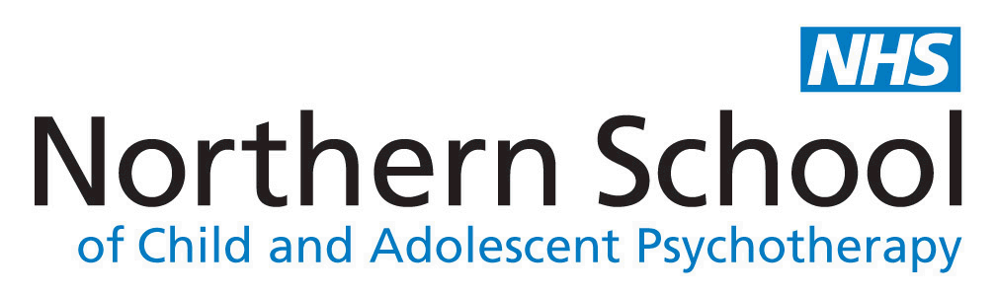
Please send your completed application form to:
Mirriam Maganga
Business and Training Support Officer
NSCAP
Bevan House
34-36 Springwell Road
Leeds
LS12 1AW

Or email : mmaganga@nhs.net

