The Transpennine Partnership

Psychoanalytic Clinical Seminars

The Transpennine Partnership (TPP) in collaboration with NSCAP is delighted to announce the establishment of The Psychoanalytic Clinical Seminars in Manchester.

Outline
The first year will consist of two series of 5 monthly clinical seminars which will run on Friday evenings in the first series, and on Saturday mornings in the second series. ** Please see footnote on page 2 for more details on the second year of seminars.

The seminars will be facilitated by senior psychoanalysts and psychoanalytic psychotherapists and will offer participants the opportunity to join an ongoing clinical discussion giving the opportunity to explore clinical work within a group setting using a psychoanalytic lens.

Each seminar will have a maximum of 10 participants and run monthly for one and a half hours. Seminars will be offered in blocks of 5 (there will be a discounted price for booking two blocks).

Cost
The cost of the seminars is £260 for each series of five seminars, or £480 for ten seminars.

Aims
The clinical seminars aim:
- To aid participants understanding of psychoanalytic processes; including transference and countertransference dynamics.
- To offer the opportunity within a group format to explore psychoanalytic understanding of psychopathology and development as it relates to the clinical presentation.
- To deepen clinical understanding of the unconscious and its impact within the clinical arena and its relation to the clinical therapeutic task.

Who should attend
Psychoanalytic and psychodynamic clinicians both experienced and in training. Counsellors and (other) psychotherapists with an interest in psychoanalytic thinking and unconscious processes should also attend.

Where
St Thomas Centre, Ardwick Green, Manchester M12 6FZ

When
The first series of clinical seminars will begin on Friday 5th of April 2019 at 6pm until 7:30pm, with the following seminars scheduled to run at the same time on:
10th May 2019
7th June 2019
5th July 2019
26th July 2019.

The first series will be facilitated by Dr Gearoid Fitzgerald. Dr Fitzgerald was until recently consultant psychiatrist in psychotherapy in Leeds. He is a practising psychoanalyst and member of the British Psychoanalytical Society.

The second series will begin on Saturday morning 16th November 2019 from 10am until 11:30am, with the following seminars scheduled to run at the same time on:
14th December 2019
11th January 2020
15th February 2020
14th March 2020.

The second series will be facilitated by Jan McGregor Hepburn. Jan is a psychoanalytic psychotherapist in private practice in Northumberland. She is registrar for the British Psychoanalytic Council and on the training committee of the North of England Training in Psychoanalytic Psychotherapy.

**Dates for the second year will be released during 2020 with these seminars running on Friday evenings, and will be facilitated by Dr Liz Gibb and Susie Godsil.

APPLICATION FORM

Personal Details:

Title:………………Name:………………………………………………………….....................................................................................................................................................................................................................................................................

Occupation:………………………………………………………………………………………………………………………………………………………………………………………………………………………………………………………………………………………………………………………………………

Address for correspondence:………………………………………………………………………………………………………………………………………………………………………………………………………………………………………………………………………………………………………………………………
………………………………………………………………………………..……...........................................................................................................................................................................................................................................................................
Postcode:…..…………………………………………………………….Telephone:………………………………………………………………………..

Email address:……………………………………………………………………………………………………………………………………………………..

Any Special Requirements:…………………………………………………………………………………………………………………………..……………………………………………………………………………………………………………………………………………………………………………………………………

I wish to attend the first/second series (circle or delete as appropriate) of 5 seminars for £260.
I wish to attend both series of 10 seminars for £480.

Please invoice me/my organization……..….… or I have enclosed a cheque for ……………

* Please make cheques payable to Leeds and York Partnership NHS Foundation Trust

Keeping in contact:

Your personal information will be held on our database and used to process your application.

NSCAP would like to keep you informed of other events and activities that we feel are relevant to you. If you are happy for us to do this, please tick this box

If you do not want to be contacted about other events and activities, please tick this box .

Signature………………………………………………

Date………………………………………………………
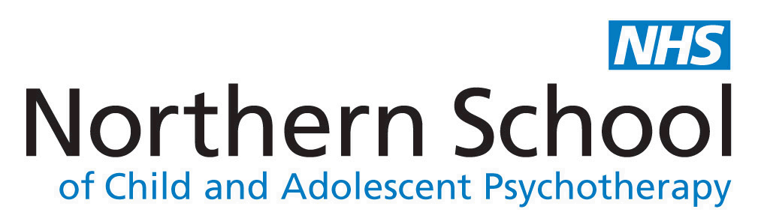
Please send your completed application form to:
Mirriam Maganga
Business and Training Support Officer
NSCAP
Bevan House
34-36 Springwell Road
Leeds
LS12 1AW

Or email : mmaganga@nhs.net

